Panel101-Panel Model

Nguyen Quang Dong

30/8/2023

library(foreign); library(car)

## Loading required package: carData

library(lmtest)

## Loading required package: zoo

##   
## Attaching package: 'zoo'

## The following objects are masked from 'package:base':  
##   
## as.Date, as.Date.numeric

library(AER)

## Loading required package: sandwich

## Loading required package: survival

library(plm)  
library(stargazer)

##   
## Please cite as:

## Hlavac, Marek (2022). stargazer: Well-Formatted Regression and Summary Statistics Tables.

## R package version 5.2.3. https://CRAN.R-project.org/package=stargazer

panel101=read.dta("D:/dataR/Panel/Panel101.dta")  
dim(panel101 )

## [1] 70 8

head(panel101,1)

## country year y y_bin x1 x2 x3 opinion  
## 1 A 1990 1342787840 1 0.2779036 -1.107956 0.2825536 Str agree

coplot(y~x1|country, type="p", data=panel101)

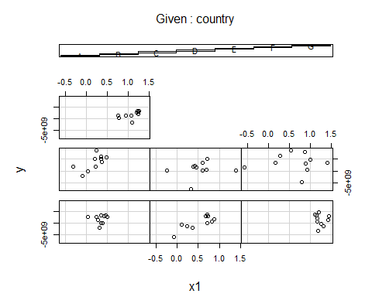

# coplot  
library(gplots)

##   
## Attaching package: 'gplots'

## The following object is masked from 'package:stats':  
##   
## lowess

plotmeans(y ~ country, main="Heterogeineityacross countries", data=panel101)

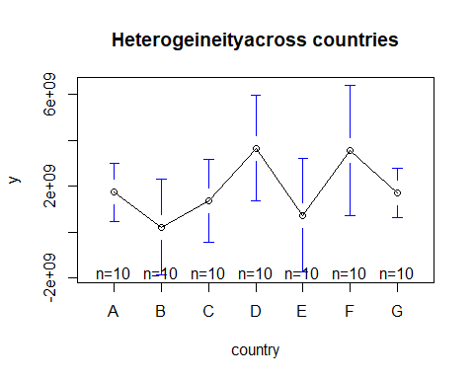

scatterplot(y~year|country, boxplots=FALSE, smooth=TRUE, reg.line=FALSE, data=panel101)

## Warning in plot.window(...): "reg.line" is not a graphical parameter

## Warning in plot.xy(xy, type, ...): "reg.line" is not a graphical parameter

## Warning in axis(side = side, at = at, labels = labels, ...): "reg.line" is not  
## a graphical parameter  
  
## Warning in axis(side = side, at = at, labels = labels, ...): "reg.line" is not  
## a graphical parameter

## Warning in box(...): "reg.line" is not a graphical parameter

## Warning in title(...): "reg.line" is not a graphical parameter

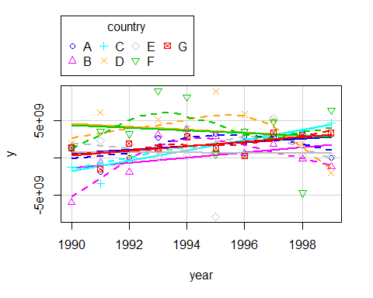

## PANEL MODELS

# INPUT DATA

## ƯỚC LƯỢNG GỘP POLS

print('Phương pháp POLS=OLS')

## [1] "Phương pháp POLS=OLS"

pols_1=lm(y~x1,data=panel101)  
summary(pols_1)

##   
## Call:  
## lm(formula = y ~ x1, data = panel101)  
##   
## Residuals:  
## Min 1Q Median 3Q Max   
## -9.546e+09 -1.578e+09 1.554e+08 1.422e+09 7.183e+09   
##   
## Coefficients:  
## Estimate Std. Error t value Pr(>|t|)   
## (Intercept) 1.524e+09 6.211e+08 2.454 0.0167 *  
## x1 4.950e+08 7.789e+08 0.636 0.5272   
## ---  
## Signif. codes: 0 '***' 0.001 '**' 0.01 '*' 0.05 '.' 0.1 ' ' 1  
##   
## Residual standard error: 3.028e+09 on 68 degrees of freedom  
## Multiple R-squared: 0.005905, Adjusted R-squared: -0.008714   
## F-statistic: 0.4039 on 1 and 68 DF, p-value: 0.5272

print('"polling" được chọn trong phương pháp plm chính là OLS')

## [1] "\"polling\" được chọn trong phương pháp plm chính là OLS"

pooling_1=plm(y~x1,data=panel101,index=c("country","year"),model="pooling") #   
summary(pooling_1)

## Pooling Model  
##   
## Call:  
## plm(formula = y ~ x1, data = panel101, model = "pooling", index = c("country",   
## "year"))  
##   
## Balanced Panel: n = 7, T = 10, N = 70  
##   
## Residuals:  
## Min. 1st Qu. Median Mean 3rd Qu. Max.   
## -9.55e+09 -1.58e+09 1.55e+08 0.00e+00 1.42e+09 7.18e+09   
##   
## Coefficients:  
## Estimate Std. Error t-value Pr(>|t|)   
## (Intercept) 1524319070 621072624 2.4543 0.01668 *  
## x1 494988914 778861261 0.6355 0.52722   
## ---  
## Signif. codes: 0 '***' 0.001 '**' 0.01 '*' 0.05 '.' 0.1 ' ' 1  
##   
## Total Sum of Squares: 6.2729e+20  
## Residual Sum of Squares: 6.2359e+20  
## R-Squared: 0.0059046  
## Adj. R-Squared: -0.0087145  
## F-statistic: 0.403897 on 1 and 68 DF, p-value: 0.52722

## ƯỚC LƯỢNG MÔ HÌNH TÁC ĐỘNG CỐ ĐỊNH-FEM

# Testing for time-fixed effects- biến giả theo thời gian, gọi chung là SLDV-Structural Lagrange and Dummy Variable  
fixed_time=plm(y~x1+factor(year),data=panel101,index=c("country", "year"), model="within") # ,index=c("country","year"),model="within") #   
summary(fixed_time)

## Oneway (individual) effect Within Model  
##   
## Call:  
## plm(formula = y ~ x1 + factor(year), data = panel101, model = "within",   
## index = c("country", "year"))  
##   
## Balanced Panel: n = 7, T = 10, N = 70  
##   
## Residuals:  
## Min. 1st Qu. Median Mean 3rd Qu. Max.   
## -7.92e+09 -1.05e+09 -1.40e+08 0.00e+00 1.63e+09 5.49e+09   
##   
## Coefficients:  
## Estimate Std. Error t-value Pr(>|t|)   
## x1 1389050354 1319849567 1.0524 0.29738   
## factor(year)1991 296381559 1503368528 0.1971 0.84447   
## factor(year)1992 145369666 1547226548 0.0940 0.92550   
## factor(year)1993 2874386795 1503862554 1.9113 0.06138 .  
## factor(year)1994 2848156288 1661498927 1.7142 0.09233 .  
## factor(year)1995 973941306 1567245748 0.6214 0.53698   
## factor(year)1996 1672812557 1631539254 1.0253 0.30988   
## factor(year)1997 2991770063 1627062032 1.8388 0.07156 .  
## factor(year)1998 367463593 1587924445 0.2314 0.81789   
## factor(year)1999 1258751933 1512397632 0.8323 0.40898   
## ---   
## Signif. codes: 0 '***' 0.001 '**' 0.01 '*' 0.05 '.' 0.1 ' ' 1  
##   
## Total Sum of Squares: 5.2364e+20  
## Residual Sum of Squares: 4.0201e+20  
## R-Squared: 0.23229  
## Adj. R-Squared: 0.00052851  
## F-statistic: 1.60365 on 10 and 53 DF, p-value: 0.13113

print('Các hệ số chặn')

## [1] "Các hệ số chặn"

fixef(fixed_time)

## A B C D E F   
## -90350477 -1842557091 -1719379833 2029595478 -1363667466 1347485302   
## G   
## -1146682473

# Testing for individual-fixed effects   
fixed_indi=plm(y~x1+factor(country),data=panel101,index=c("country", "year"), model="within")  
summary(fixed_indi)

## Oneway (individual) effect Within Model  
##   
## Call:  
## plm(formula = y ~ x1 + factor(country), data = panel101, model = "within",   
## index = c("country", "year"))  
##   
## Balanced Panel: n = 7, T = 10, N = 70  
##   
## Residuals:  
## Min. 1st Qu. Median Mean 3rd Qu. Max.   
## -8.63e+09 -9.70e+08 5.40e+08 0.00e+00 1.39e+09 5.61e+09   
##   
## Coefficients:  
## Estimate Std. Error t-value Pr(>|t|)   
## x1 2475617827 1106675594 2.237 0.02889 *  
## ---  
## Signif. codes: 0 '***' 0.001 '**' 0.01 '*' 0.05 '.' 0.1 ' ' 1  
##   
## Total Sum of Squares: 5.2364e+20  
## Residual Sum of Squares: 4.8454e+20  
## R-Squared: 0.074684  
## Adj. R-Squared: -0.029788  
## F-statistic: 5.00411 on 1 and 62 DF, p-value: 0.028892

scatterplot(fitted(fixed_indi)~panel101$x1|panel101$country, boxplots=FALSE, xlab="x1", ylab="yhat",smooth=FALSE)  
abline(lm(panel101$y~panel101$x1),lwd=3, col="red")

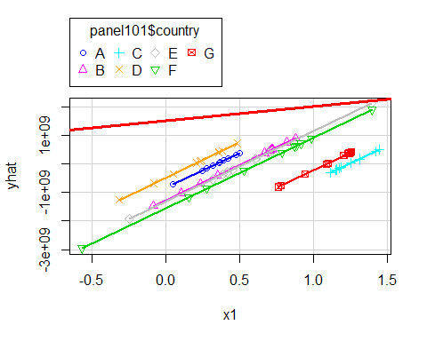

print('Các hệ số chặn')

## [1] "Các hệ số chặn"

fixef(fixed_indi)

## A B C D E F   
## 880542404 -1057858363 -1722810755 3162826897 -602622000 2010731793   
## G   
## -984717493

fixed_1=plm(y~x1,data=panel101,index=c("country", "year"), model="within")  
summary(fixed_1)

## Oneway (individual) effect Within Model  
##   
## Call:  
## plm(formula = y ~ x1, data = panel101, model = "within", index = c("country",   
## "year"))  
##   
## Balanced Panel: n = 7, T = 10, N = 70  
##   
## Residuals:  
## Min. 1st Qu. Median Mean 3rd Qu. Max.   
## -8.63e+09 -9.70e+08 5.40e+08 0.00e+00 1.39e+09 5.61e+09   
##   
## Coefficients:  
## Estimate Std. Error t-value Pr(>|t|)   
## x1 2475617827 1106675594 2.237 0.02889 *  
## ---  
## Signif. codes: 0 '***' 0.001 '**' 0.01 '*' 0.05 '.' 0.1 ' ' 1  
##   
## Total Sum of Squares: 5.2364e+20  
## Residual Sum of Squares: 4.8454e+20  
## R-Squared: 0.074684  
## Adj. R-Squared: -0.029788  
## F-statistic: 5.00411 on 1 and 62 DF, p-value: 0.028892

print('Các hệ số chặn')

## [1] "Các hệ số chặn"

fixef(fixed_1)

## A B C D E F   
## 880542404 -1057858363 -1722810755 3162826897 -602622000 2010731793   
## G   
## -984717493

# Testing time-fixed effects. The null is that no time-fixed effects needed  
# pFtest(fixed, ols) # Testing for fixed effects, null: OLS better than fixed  
pFtest(fixed_time, fixed_1)

##   
## F test for individual effects  
##   
## data: y ~ x1 + factor(year)  
## F = 1.209, df1 = 9, df2 = 53, p-value = 0.3094  
## alternative hypothesis: significant effects

bptest(fixed_1)

##   
## studentized Breusch-Pagan test  
##   
## data: fixed_1  
## BP = 1.9332, df = 1, p-value = 0.1644

## ƯỚC LƯỢNG MO HÌNH TÁC ĐỘNG NGẪU NHIÊN REM

random_1=plm(y~x1,data=panel101,index=c("country","year"),model="random") # random model  
summary(random_1)

## Oneway (individual) effect Random Effect Model   
## (Swamy-Arora's transformation)  
##   
## Call:  
## plm(formula = y ~ x1, data = panel101, model = "random", index = c("country",   
## "year"))  
##   
## Balanced Panel: n = 7, T = 10, N = 70  
##   
## Effects:  
## var std.dev share  
## idiosyncratic 7.815e+18 2.796e+09 0.873  
## individual 1.133e+18 1.065e+09 0.127  
## theta: 0.3611  
##   
## Residuals:  
## Min. 1st Qu. Median Mean 3rd Qu. Max.   
## -8.94e+09 -1.51e+09 2.82e+08 0.00e+00 1.56e+09 6.63e+09   
##   
## Coefficients:  
## Estimate Std. Error z-value Pr(>|z|)  
## (Intercept) 1037014284 790626206 1.3116 0.1896  
## x1 1247001782 902145601 1.3823 0.1669  
##   
## Total Sum of Squares: 5.6595e+20  
## Residual Sum of Squares: 5.5048e+20  
## R-Squared: 0.02733  
## Adj. R-Squared: 0.013026  
## Chisq: 1.91065 on 1 DF, p-value: 0.16689

bptest(random_1)

##   
## studentized Breusch-Pagan test  
##   
## data: random_1  
## BP = 1.9332, df = 1, p-value = 0.1644

## FEM HAY REM?

# fixed_1=plm(y~x1,data=panel101,index=c("country", "year"), model="within") #   
  
phtest(fixed_1,random_1) # Hausman test

##   
## Hausman Test  
##   
## data: y ~ x1  
## chisq = 3.674, df = 1, p-value = 0.05527  
## alternative hypothesis: one model is inconsistent

```